# Sprint 2 Plan: SlugManager

Team: Asher Etherington, Kenneth Losier, Mia Santos, Nathan Le, Poppy Garner, Gino Zarich

Sprint Completion date: 5/7/24

Revision Number and Date:

## Goals:

* For users to be able to create projects and see which ones they created
* For users to be able to add team members to the project and assign tasks to them
* For team members to be able to see what projects they are included in

## Task Listing:

User Story 2 (US.A)

As a user, I want to be able to create projects, and I should be the administrator of any project I make [Story Points: 8]

(US.B) As a user, I want to be able to add team members to a project that I have made based on their username. [Story Points: 3]

* Task 1: Make .ejs file for main homepage. (time estimate: 6 hours)
  + Should include a button where users can create projects.
  + Homepage should display all current projects that the user is a part of.
    - Displayed projects should have their project name and admin name clearly displayed.
* Task 2: Make .ejs file to handle the form where users will create a new project. (time estimate: 3 hours)
  + An app.post method should also be added to the main express server file to handle project creation.
    - Project Title
    - Add users to project button
* Task 3: The navbar should be different depending on which page is being displayed. (time estimate: 1 hour)
  + Once the user signs in, the navbar should not show a register or login.
  + Once the user clicks on a project, the navbar should show a task creation button instead of a project creation button.
* Task 4: Make .ejs for individual project pages. (time estimate: 4 hours)
  + If the current user is the project admin then they should have an option to add users to the project
* Task 5 : Style all newly created .ejs files using css. Styling should follow the created figma outline. (time estimate: 4 hours)

Total for user story: 18 hours

## Team Roles:

Asher Etherington: Developer

Kenny Losier: Scrum Master

Mia Santos: Developer

Nathan Le: Developer

Poppy Garner: Developer

Gino Zarich: Project Owner

## Initial Task Assignment:

Asher Etherington: Task 2

Kenny Losier: Task 1

Mia Santos: Task 5

Nathan Le: Task 3 + 4

Poppy Garner: Task 3 + 4

Gino Zarich: Task 2

## Initial Burnup Chart:

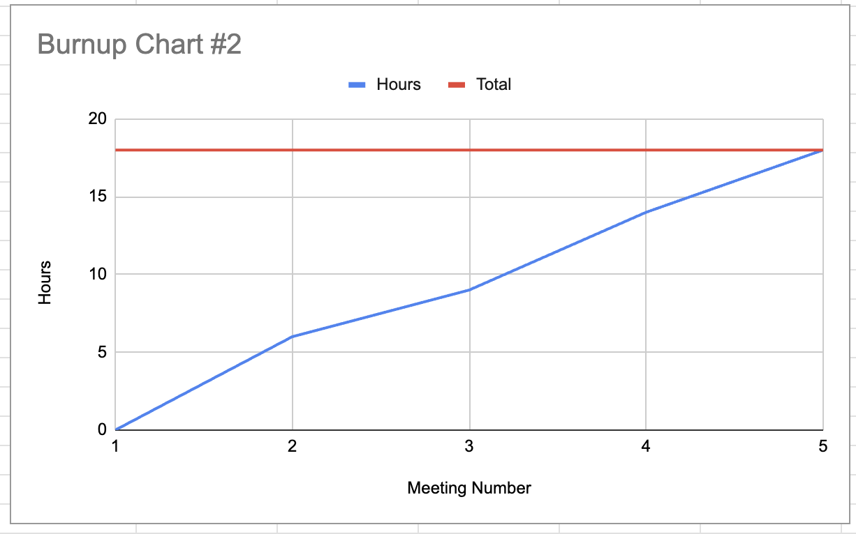

## Scrum Board:

| **User Story** | **To Do** | **In Progress** | **Done** |
| --- | --- | --- | --- |
| **US.A** | **Task 3** | **Task 1** |  |
|  | **Task 4** |  |  |
|  | **Task 5** |  |  |
| **US.B** | **Task 2** |  |  |
|  | **Task 5** |  |  |

## Scrum Times:

Monday: Team Meeting 9:15-10:15 AM

Tuesday: Meeting with TA 2:15-3:15 PM

Wednesday: Team Meeting 9:15-10:15 AM

Friday: Team Meeting 9:15 - 10:15 AM